Basic Report Writing Financial Data Mart (FDM) - Repeater Tables

Repeaters are tables in which you can insert items that are repeated in a particular order when you run the report. Examples are mailing lists and name badges.

Cognos-DEV – https://cognos-dev.udel.edu/cognos8
Cognos (production) - https://cognos.udel.edu/cognos8

- Login with your UDelNet ID and password
- Under My Actions, choose Create professional reports (Report Studio)

Navigate to the yellow content folder FDM packages, click on name

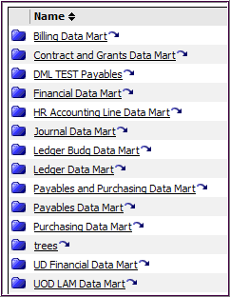
Click on UOD Financial Data Mart package (blue folder)

This will launch Report Studio

There are at least three ways to create a Repeater Table:

- Convert a List report to a Repeater (easier)
- Create a new report and select Repeater icon (harder, time-consuming)

- Add a Repeater to a report, such as a List
- Convert a List report to a Repeater

- Open UD Financial Data Mart

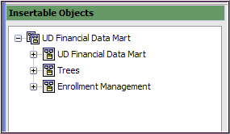

- Create a list with these fields:

Field Name | Query Subject | Folder
SPEEDTYPE_KEY | Chart of Accounts | Speedtype
SpeedType CHARTFIELD1 | Chart of Accounts | Speedtype
PURPOSE DESCR | Chart of Accounts | Purpose
FUND_TYPE_GROUP | Chart of Accounts | Purpose
PURPOSE_CURRNT_FLG | Chart of Accounts | Purpose
DEPTID1 | Chart of Accounts | Speedtype
FUND_CODE1 | Chart of Accounts | Speedtype
PROGRAM_CODE1 | Chart of Accounts | Speedtype
Speedtype CHARTFIELD2 | Chart of Accounts | Speedtype
PROJECT_ID1 | Chart of Accounts | Speedtype

- Add the pre-written prompt for Purpose

- Run the report

- Add a Filter to only return data for the current Purpose description
  - Add
  - Click the Data Items tab when the window pops up
  - Double-click PURPOSE_CURRNT_FLG to addit to the expression
  - Then type: =’C’
  - The expression should look like this:

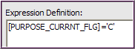

- Validate it and then click OK twice

- Run the report again
  - Notice there are no historical rows, where the PURPOSE_CURRNT_FLG is an H

- Click any part of the list
- From the Structure menu, click Convert List to Repeater

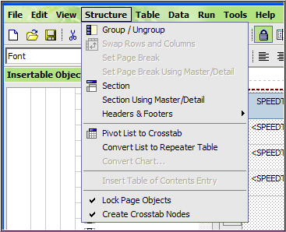

- The work area now displays a Repeater Table
  - Click just inside the repeater box until the whole thing is shaded

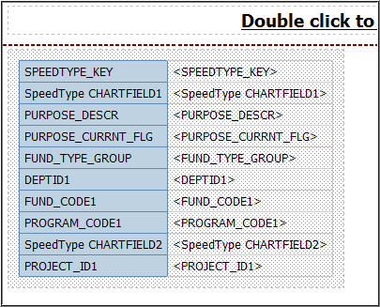
Click here

- Next, we’ll set the “repeat” pattern
  - At the top of the Properties pane, click Select Ancestor button
  - Click Repeater Table

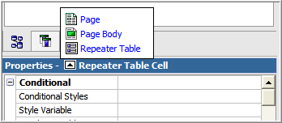

  - In Properties, under General, click Across and change number to 3
  - And change Down to 2

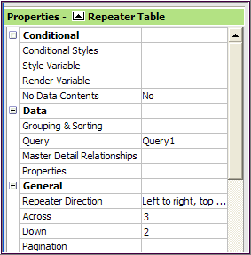

- The work area will look like this:

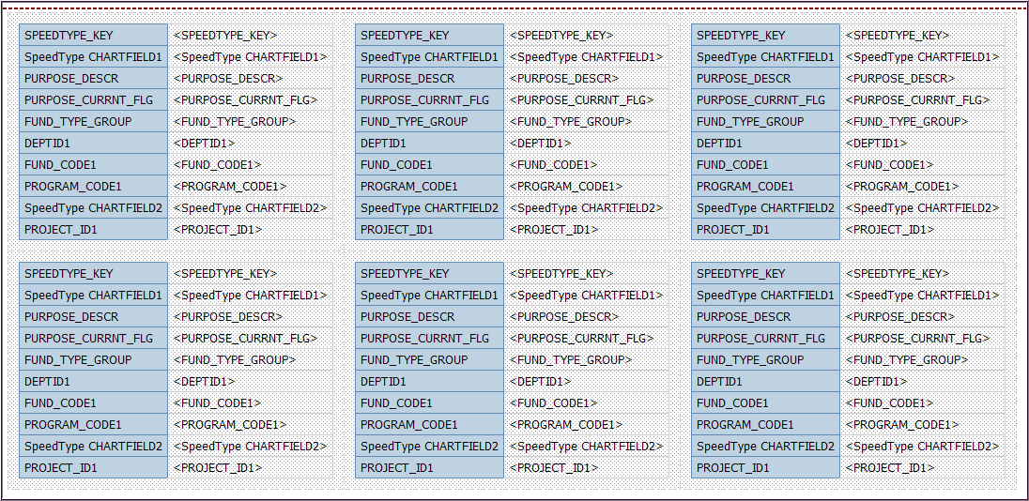

- Save the report in My Folders and name it Repeater from List

- Run the report
  - For best results, run this report with a Purpose that has multiple Speedtypes for one Purpose, such as a Basic Budget code in an academic department (e.g. CHEM110000)

- Create a new report and select Repeater icon

  - The New window appears, double-click on Repeater Table

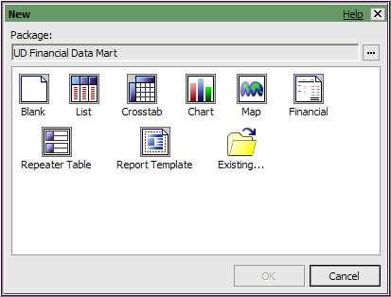

  - In the Work Area, click where it says “Drop items here…”

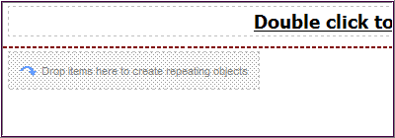

  - At the top of the Properties pane, click Select Ancestor button
    - Click Repeater Table

- In Properties set the properties of the repeater:
    - Under General, click Across: change to 4 and click Down: keep 3

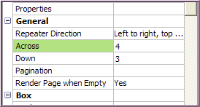
    - Under Positioning, double-click Table Properties
    - Check Fixed size and click OK

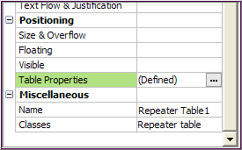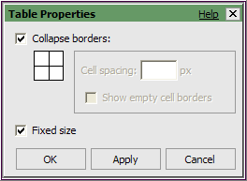

- Add five blocks which will hold five fields
- Click on the Toolbox tab
- Click on Block and drag it into where it says “Drop items here…”

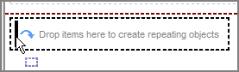
Drop the block when you see the thick, blinking line

- You will see 12 new blocks (4 across, 3 down), one in each table cell
- Drag another Block to the top left table cell – carefully drop it when a thick black, blinking line appears as shown below:

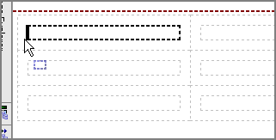
HINT – if you accidentally drop a block in the wrong place, use Undo button.

- Continue to drag & drop 3 more Blocks for a total of 5 in each table cell
- Your work area should look like this:

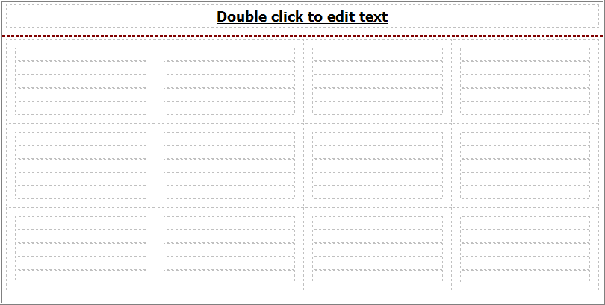
This is one repeater table

- Save the report in My Folders and name it Repeater from scratch

- In Insertable Objects, Source tab , expand UOD Labor Distrib Mart

- Add the following five fields to the upper left table cell; click & drag one field into each of the five blocks:

Field Name | Query Subject | Folder
EMPLID | LAM | Employee
NAME | LAM | Employee
CUR_DEPT_LDESCR | LAM | Employee
CUR_DEPTID | LAM | Employee
CUR_JOBCODE_LDESCR | LAM | Employee

- Your work area should look like this (partial view):

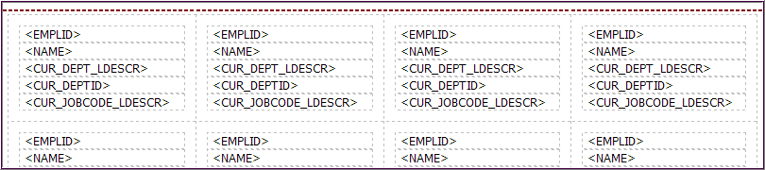

- Add a prompt for Department ID
  - Click anywhere in one of the table cells and click Filter
  - Click Add
  - Click the Data Items tab
  - Double-click CUR_DEPTID to add it to the expression
  - Type - = ?Department?
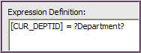
  - Validate the expression
  - If there are “no errors”, click OK

- Add a border around each table cell
  - Click any table cell in the work area
  - In the Properties pane, click the Ancestor button
  - Choose Repeater Table Cell
  - Under Box, double-click Border
  - Choose any Color, Style and Width
  - Click the Border button and click OK

- Save your work

- Run the report

3. Add a Repeater Table to a List

- Create a new List:
  - Open Report Studio using the package UOD LAM Data Mart (in FDM Packages)

  - Add these fields from the LAM query subject, Employee folder:

Field Name | Query Subject | Folder
EMPLID | LAM | Employee
NAME | LAM | Employee

- From the Toolbox tab, drag a Repeater Table to the right of NAME (look for long thin blinking line)

- Click on the Repeater Table in the work area

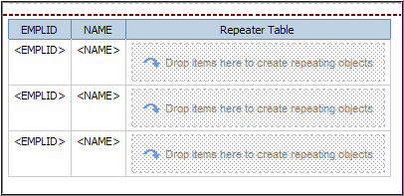

- In Properties:
  - Click the Ancestor button and choose Repeater Table
  - Data/Query - change Query 2 to Query 1 – very important!!
  - General/Across – change to 3
  - General/Down – change to 4

- From the Toolbox tab, drag a Table into the top portion of the Repeater Table

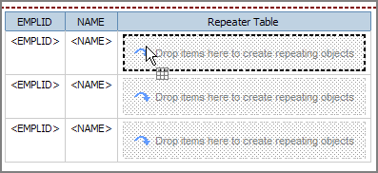

  - Insert Table – enter 3 (columns) and 8 (rows)

- From the Source tab, drag the following 8 fields to the table, starting with the top, right cell:

Field Name | Query Subject | Folder
SPEEDTYPE_KEY | LAM
PROGRAM_CODE | Chart of Accounts | Program
LASTUPDDTTM | LAM
PERCENTAGE | LAM
UODLABDST_VLD_FRM_DT | LAM
UODLABDST_VLD_TO_DT | LAM
CUR_DEPTID | LAM | Employee
CUR_DEPT_LDESCR | LAM | Employee

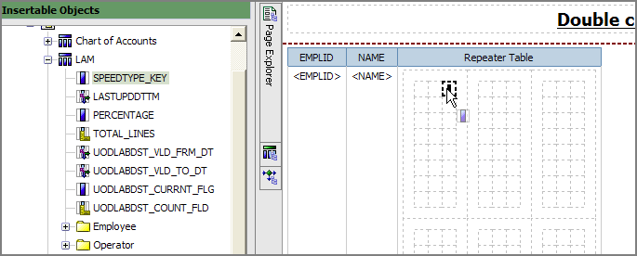

This is a partial view of what your work area will look like:

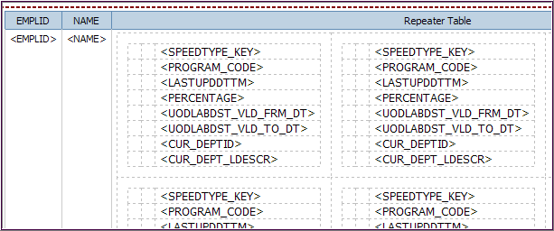

- Add descriptions to the Repeater Table in the left cells
  - From the Toolbox tab, drag a Text Item to the Table for each field
  - Type the descriptions as shown below:

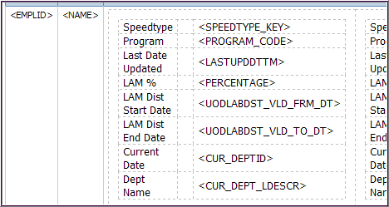

- Save the report in My Folders as Repeater LAM List – 5G

- Click Filters and add these three:
  - [SPEEDTYPE_KEY] > ‘ ‘ (This means: show any speedtype greater than blank; your report will exclude LAM rows with no Speedtype.)

  - [UOD Labor Distrib Data Mart].[LAM].[UODLABDST_CURRNT_FLG]='C'
(This means your report will only show the current LAM distribution line or lines. The other value for this field is H for historical data.)

  - [CUR_DEPTID]=?dept? (This is a prompt for department id.)

- Save the report

- Run the report

- Add some space between the descriptions and the data fields
  - From the Toolbox tab Drag a Text Item to the top, middle cell
  - Type: [space] [space]
  - You only have to do this to one cell

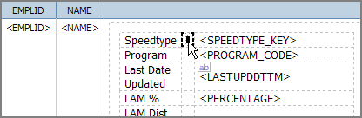

- Add formatting to the Repeater Table
  - In the work area, click the Repeater Table until the Properties pane says Repeater Table Cell
  - In Properties, go to Box/Border, click the ellipses
    - Select a Color, Style and Width according to your taste
    - Click the square box and the OK button
  - Go to Color & Background/Background Color, click the ellipses
    - Select a light color that will work with your border color

- Save

- Run the report

- Adjust the formatting colors (if needed)

